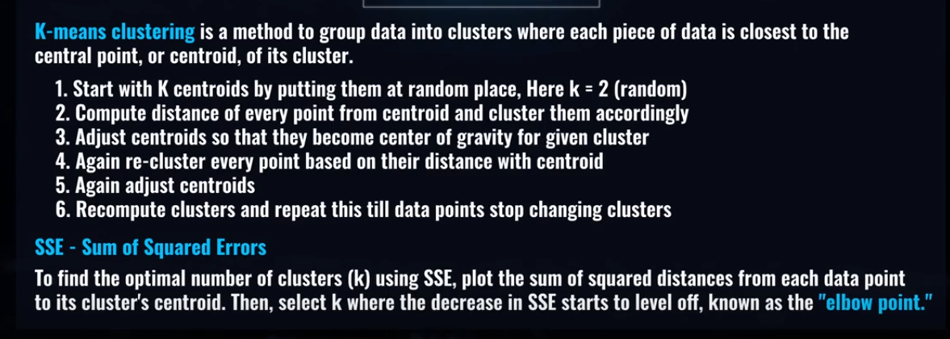

K- means is a centroid based clustering

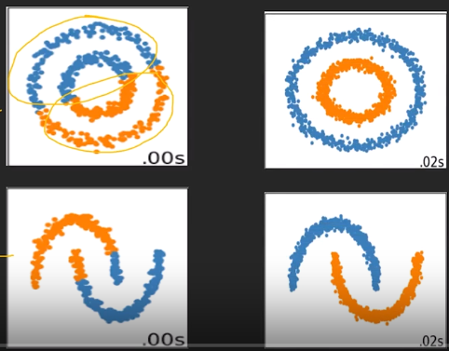

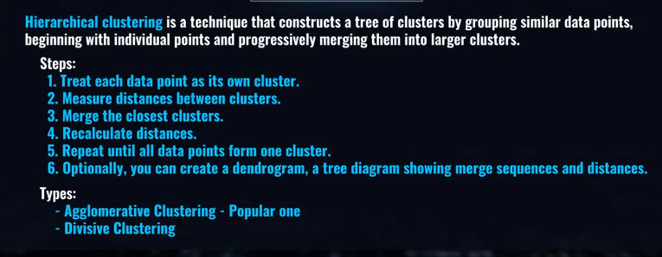

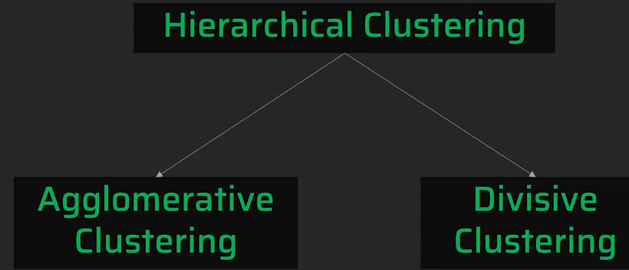

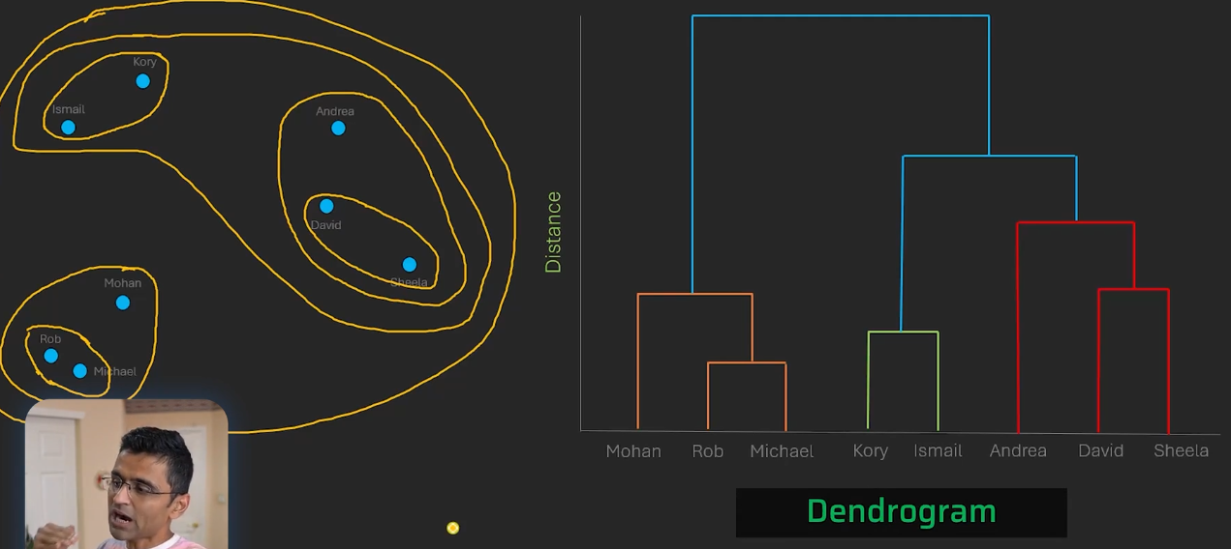

Optimal number of clusters

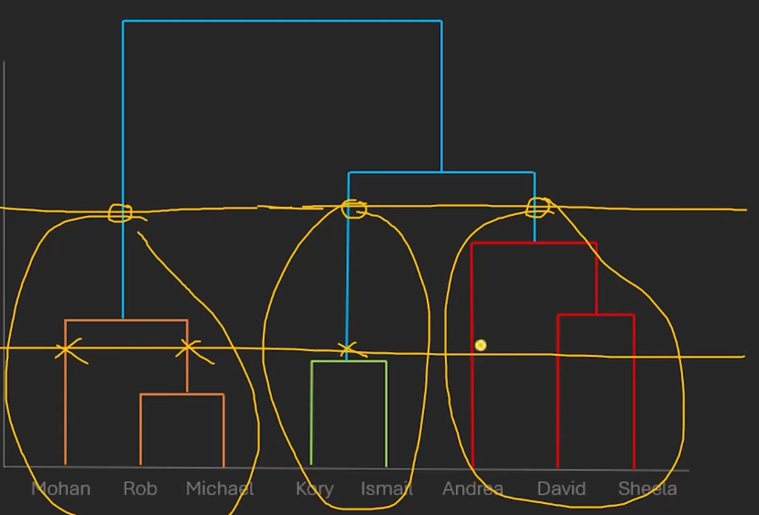

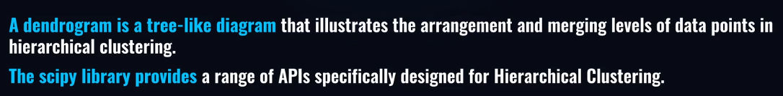

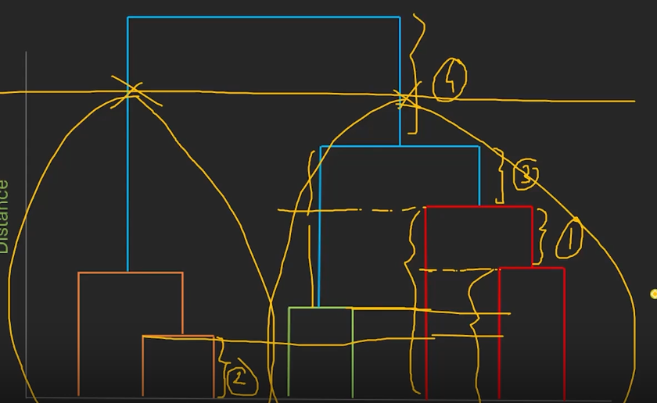

Distance b/w data point and cluster

* Average linkage

Distance b/w cluster and cluster

Average linkage Distance b/w data point and cluster

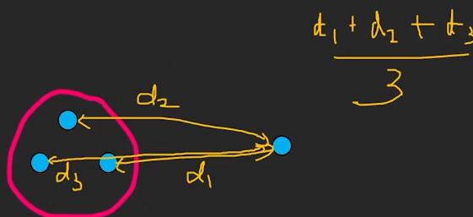

Average linkage Distance b/w cluster and cluster

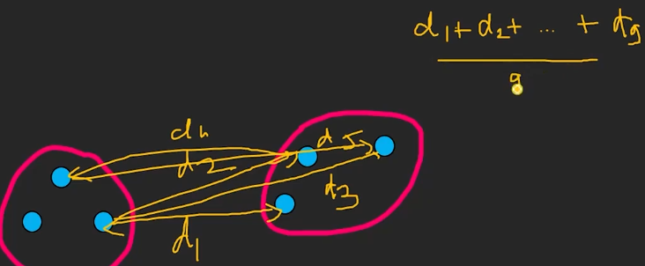

Single Linkage b/w clusters

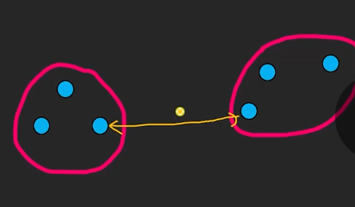

Complete Linkage b/w clusters

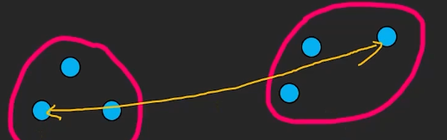

Wards Linkage – minimizes within cluster variance after merging

Weighted squares distance from centroids

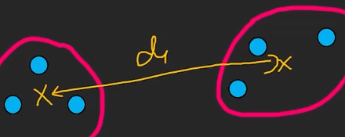

**DBSCAN** stands for:

**D**ensity-**B**ased **S**patial **C**lustering of **A**pplications with **N**oise

It's a clustering algorithm that groups points **based on density** and can detect **outliers/noise**.

**How It Works:**

* **Core Point**: A point with at least min_samples neighbors within a radius eps
* **Border Point**: Close to a core point but not enough neighbors to be core
* **Noise Point**: Not part of any cluster

DBSCAN groups **dense areas** together, and treats sparse areas as **noise or outliers**.

